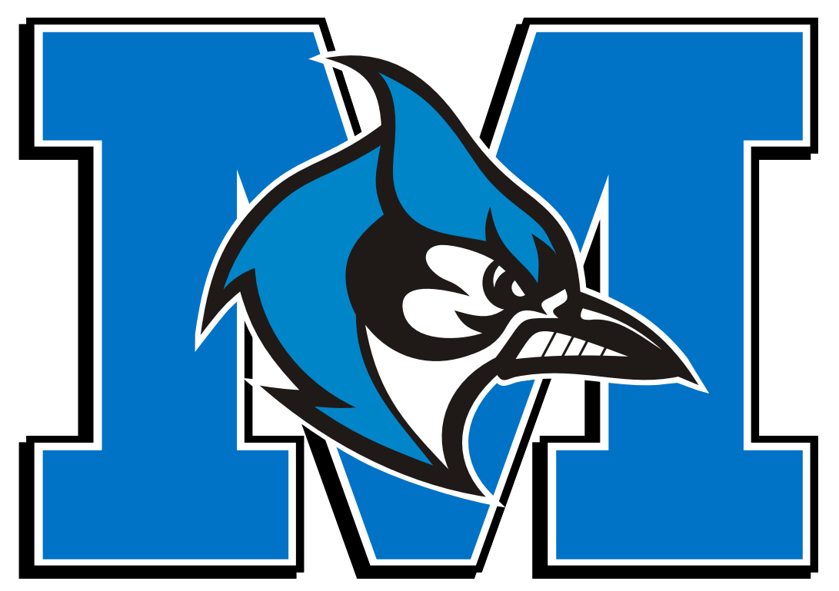
Middlesex Little League
WILL YOU SPONSOR A TEAM?
Welcome to an exciting New Year of Middlesex Baseball. Our program is under new leadership and we have some exciting changes in mind that we hope will bring a positive change to our league, town and community. We are hoping you would consider helping support Middlesex Little League by becoming a League Sponsor. In Middlesex Little League, our volunteers work hard to instill the valuable lessons in competition, sportsmanship and character as the children of our town learn the great game of baseball.
Please note that our league is Non-Profit and all sponsorships /donations are tax-deductible. Thank you for your attention and we hope we receive your support.
Sponsor’s Name: _______________________________________________________________________________
Primary Contact Person: _________________________________________________________________________
Street Address: ________________________________________________________________________________
Phone Number:________________________________________________________________________________
E-Mail:_______________________________________________________________________________________
Website: _____________________________________________________________________________________
Available Sponsorship Levels
Grand Slam Sponsor - $700 – Includes sponsor’s name on back of uniform, 4’ by 8’ sign along outfield and listing/link on our website.
Home Run Sponsor - $500 – Incudes 4’ by 8’ sign along outfield, listing/link on our website.

